Table of Contents

Getting Started: 2

Step-by-step walk through of the algorithm. 3

Example (1) 3

Step1: System of Linear Equations 3

Step2: Transforming into Matrix Form: 4

Step3: LU Decomposition 4

Step4: Solving Ly = b for y 4

Step5: Solving Ux = y for x 5

Step6: Verifying the answers: 5

Example (2): 6

Step1: System of Linear Equations 6

Step2: Transforming into Matrix Form: 6

Step3: LU Decomposition 6

Step4: Solving Ly = b for y 6

Step5: Solving Ux = y for x 7

Step6: Verifying the answers: 7

Coding a simple serial program to do this calculation: 8

Testing the program: 8

Running the program serially: 8

Next steps: 8

Appendix – 1 (Step by step solution of example 1 using LU Decomposition) 9

Appendix –2 (Basic Example code to solve a 3x3 matrix using LU Decomposition) 12

# Getting Started:

First, we started a git repo and created directories with file structures that could be useful in our project. We may not end up using all those files, but this structure will be helpful in enforcing modularity into our program.

Before we start any actual coding, we made sure to review how the actual LU Decomposition works, and just see how in general a set of linear equations is transferred into a matrix that’s to be decomposed and solved using LU Decomposition.

# Step-by-step walk through of the algorithm.

(Making sense of the program we’re making): Those examples will be used to code our initial algorithm and verify its working as expected.

## Example (1)

## Step1: System of Linear Equations

Let’s start with the following system of equations:

$2x_{1}+3x_{2}-x_{3}=5$

$$4x_{1}+x_{2}+2x_{3}=6$$

$$-2x_{1}+2x_{2}+3x_{3}=8$$

­­­

## Step2: Transforming into Matrix Form:

This system can be represented in matrix form as Ax=b, where:

$$A=\left(\begin{matrix}2 & 3 & -1 \\ 4 & 1 & 2 \\ -2 & 2 & 3\end{matrix}\right), x=\left(\begin{matrix}x_{1} \\ x_{2} \\ x_{3}\end{matrix}\right), b=\left(\begin{matrix}5 \\ 6 \\ 8\end{matrix}\right)$$

## Step3: LU Decomposition

Next, we decompose A into L and U, where L is a lower triangular matrix and U is an upper triangular matrix.

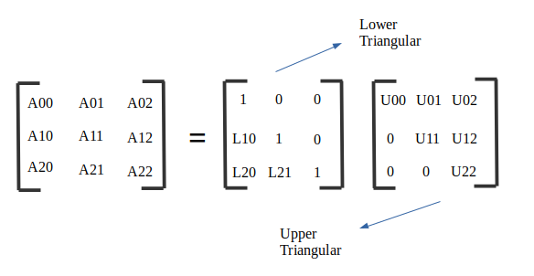

In our example:

(Step by step derivations of the LU matrices in the appendix)

$$L=\left(\begin{matrix}1 & 0 & 0 \\ 2 & 1 & 0 \\ -1 & -1 & 1\end{matrix}\right), U=\left(\begin{matrix}2 & 3 & -1 \\ 0 & -5 & 4 \\ 0 & 0 & 6\end{matrix}\right)$$

## Step4: Solving Ly = b for y

Given L and b, we solve for y (which is an intermediate vector, not the final solution).

Using forward substitution.

$$Ly=b, \left(\begin{matrix}1 & 0 & 0 \\ 2 & 1 & 0 \\ -1 & -1 & 1\end{matrix}\right)\left(\begin{matrix}y_{1} \\ y_{2} \\ y_{3}\end{matrix}\right)=\left(\begin{matrix}5 \\ 6 \\ 8\end{matrix}\right)$$

$$y_{1}= 5 (from the first row of L and b)$$

$$2y_{1}+y_{2}=6, 2×5+y2=6, y2 = -4$$

$$-y1-y2+y3 =8, -5-\left(-4\right)+y3 = 8, y3 = 9$$

$$So$$

$$∴ y=\left(\begin{matrix}5 \\ -4 \\ 9\end{matrix}\right),$$

## Step5: Solving Ux = y for x

Now, with U and y, we can solve for x using backward substitution.

$$Ux=y, \left(\begin{matrix}2 & 3 & -1 \\ 0 & -5 & 4 \\ 0 & 0 & 6\end{matrix}\right)\left(\begin{matrix}x_{1} \\ x_{2} \\ x_{3}\end{matrix}\right)=\left(\begin{matrix}5 \\ -4 \\ 9\end{matrix}\right)$$

$$6x_{3}=9 , ∴x_{3}=\frac{3}{2}, \left(from the last row of U and y\right)$$

$$-5x_{2}+4x_{3}=-4, -5x_{2}+4×\left(\frac{3}{2}\right)=-4, x_{2}=2$$

$$2x_{1}+3x_{2}-x_{3}=5, 2x_{1}+3×2-\frac{3}{2}=5, x_{1}=\frac{1}{4}$$

$$∴ x=\left(\begin{matrix}\frac{1}{4} \\ 2 \\ \frac{3}{2}\end{matrix}\right), ∴x_{1}=\frac{1}{4}, x_{2}=2, x_{3}=\frac{3}{2}$$

## Step6: Verifying the answers:

$$2x_{1}+3x_{2}-x_{3}=5$$

$$2\left(\frac{1}{4}\right)+3\left(2\right)-\left(\frac{3}{2}\right)=5, \#$$

$$4x_{1}+x_{2}+2x_{3}=6$$

$$4\left(\frac{1}{4}\right)+\left(2\right)+2\left(\frac{3}{2}\right)=6, \#$$

$$-2x_{1}+2x_{2}+3x_{3}=8$$

$$-2\left(\frac{1}{4}\right)+2\left(2\right)+3\left(\frac{3}{2}\right)=8, \#$$

# Example (2):

## Step1: System of Linear Equations

$$x_{1}+x_{2}-x_{3}=4$$

$$x_{1}-2x_{2}+3x_{3}=-6$$

$$2x_{1}+3_{x2}+x_{3}=7$$

## Step2: Transforming into Matrix Form:

$$\left(\begin{matrix}1 & 1 & -1 \\ 1 & -2 & 3 \\ 2 & 3 & 1\end{matrix}\right)\left(\begin{matrix}x_{1} \\ x_{2} \\ x_{3}\end{matrix}\right)=\left(\begin{matrix}4 \\ -6 \\ 7\end{matrix}\right)$$

$$A=\left(\begin{matrix}1 & 1 & -1 \\ 1 & -2 & 3 \\ 2 & 3 & 1\end{matrix}\right), x=\left(\begin{matrix}x_{1} \\ x_{2} \\ x_{3}\end{matrix}\right), b=\left(\begin{matrix}4 \\ -6 \\ 7\end{matrix}\right)$$

## Step3: LU Decomposition

$$L=\left(\begin{matrix}1 & 0 & 0 \\ 1 & 1 & 0 \\ 2 & -\frac{1}{3} & 1\end{matrix}\right), U=\left(\begin{matrix}1 & 1 & -1 \\ 0 & -3 & 4 \\ 0 & 0 & \frac{13}{3}\end{matrix}\right)$$

## Step4: Solving Ly = b for y

Given L and b, we solve for y (which is an intermediate vector, not the final solution).

Using forward substitution.

$$Ly=b, \left(\begin{matrix}1 & 0 & 0 \\ 1 & 1 & 0 \\ 2 & -\frac{1}{3} & 1\end{matrix}\right)\left(\begin{matrix}y_{1} \\ y_{2} \\ y_{3}\end{matrix}\right)=\left(\begin{matrix}4 \\ -6 \\ 7\end{matrix}\right)$$

$$y_{1}= 4 (from the first row of L and b)$$

$$y_{1}+y_{2}=-6, y2 = -10$$

$$2y_{1}-\frac{1}{3}y_{2}+y_{3} =7, y_{3}=-\frac{13}{3}$$

$$So$$

$$∴ y=\left(\begin{matrix}4 \\ -10 \\ -\frac{13}{3}\end{matrix}\right),$$

## Step5: Solving Ux = y for x

Now, with U and y, we can solve for x using backward substitution.

$$Ux=y, \left(\begin{matrix}1 & 1 & -1 \\ 0 & -3 & 4 \\ 0 & 0 & \frac{13}{3}\end{matrix}\right)\left(\begin{matrix}x_{1} \\ x_{2} \\ x_{3}\end{matrix}\right)=\left(\begin{matrix}4 \\ -10 \\ -\frac{13}{3}\end{matrix}\right)$$

$$\frac{13}{3}x_{3}=-\frac{13}{3} , ∴x_{3}=-1, \left(from the last row of U and y\right)$$

$$-3x_{2}+4x_{3}=-10, x_{2}=2$$

$$x_{1}+x_{2}-x_{3}=4, x_{1}=1$$

$$∴ x=\left(\begin{matrix}1 \\ 2 \\ -1\end{matrix}\right), ∴x_{1}=1, x_{2}=2, x_{3}=-1$$

## Step6: Verifying the answers:

$$x_{1}+x_{2}-x_{3}=4$$

$$x_{1}-2x_{2}+3x_{3}=-6$$

$$2x_{1}+3_{x2}+x_{3}=7$$

$$x_{1}+x_{2}-x_{3}=4$$

$$\left(1\right)+\left(2\right)-\left(-1\right)=4, \#$$

$$x_{1}-2x_{2}+3x_{3}=-6$$

$$\left(1\right)-2\left(2\right)+3\left(-1\right)=-6, \#$$

$$2x_{1}+3_{x2}+x_{3}=7$$

$$2\left(1\right)+3\left(2\right)+\left(-1\right)=7, \#$$

# Coding a simple serial program to do this calculation:

To get started, we will code a simple C code implementing this algorithm, then we’ll use those same examples above to verify the correctness of that algorithm. Next, we’ll improve the algorithm to work on bigger matrices, and will use pthreads.

Code structure:

The matrix is defined in the main here, as a next step, we’ll have It defined in a separate file or function. (The complete code is in appendix 2).

# Testing the program:

# Running the program serially:

# Next steps:

(increase the size of the test matrix)

(Enhance the parallel programming implementation of the program.

# Appendix – 1 (Step by step solution of example 1 using LU Decomposition)

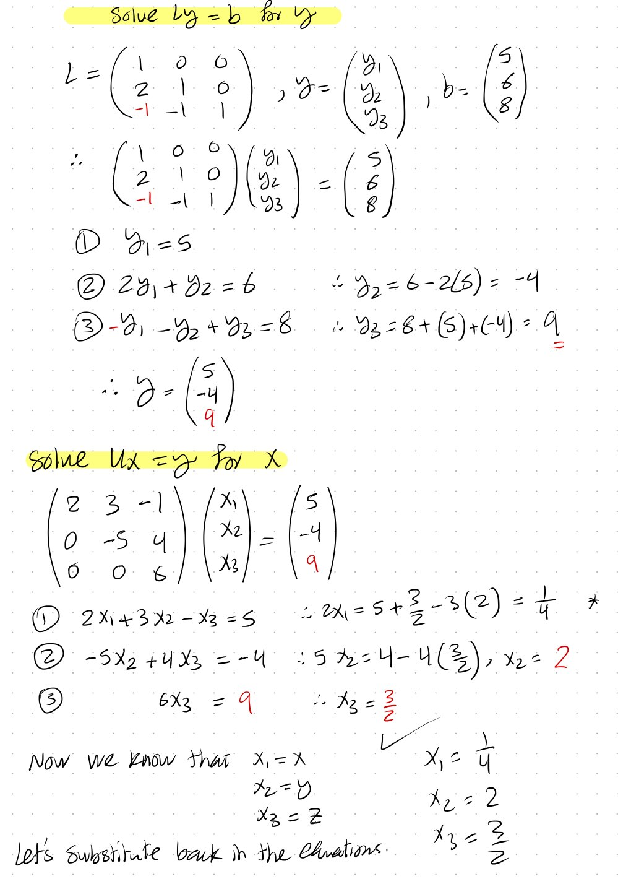

# Appendix –2 (Basic Example code to solve a 3x3 matrix using LU Decomposition)

// Author: Mohamed Ghonim

// Created: 02/18/2024

// Last Modified: 02/18/2024

// Functionality: Perform LU decomposition and solve a system of linear equations using forward and backward substitution.

// Version: 0.1

#include <stdio.h>

#define N 3 // Size of the matrix (3x3)

// Function to perform LU decomposition

void luDecomposition(double A[N][N], double L[N][N], double U[N][N]) {

int i, j, k;

for (i = 0; i < N; i++) {

for (j = 0; j < N; j++) {

if (j < i)

L[j][i] = 0;

else {

L[j][i] = A[j][i];

for (k = 0; k < i; k++) {

L[j][i] = L[j][i] - L[j][k] * U[k][i];

}

}

}

for (j = 0; j < N; j++) {

if (j < i)

U[i][j] = 0;

else if (j == i)

U[i][j] = 1;

else {

U[i][j] = A[i][j] / L[i][i];

for (k = 0; k < i; k++) {

U[i][j] = U[i][j] - ((L[i][k] * U[k][j]) / L[i][i]);

}

}

}

}

}

// Function to solve the equation Ly = b

void forwardSubstitution(double L[N][N], double b[N], double y[N]) {

for (int i = 0; i < N; i++) {

y[i] = b[i];

for (int j = 0; j < i; j++) {

y[i] -= L[i][j] * y[j];

}

y[i] = y[i] / L[i][i];

}

}

// Function to solve the equation Ux = y

void backwardSubstitution(double U[N][N], double y[N], double x[N]) {

for (int i = N - 1; i >= 0; i--) {

x[i] = y[i];

for (int j = i + 1; j < N; j++) {

x[i] -= U[i][j] * x[j];

}

// No division by U[i][i] since U[i][i] = 1

}

}

int main() {

double A[N][N] = {{2, 3, -1}, {4, 1, 2}, {-2, 2, 3}};

double b[N] = {5, 6, 8};

double L[N][N] = {0};

double U[N][N] = {0};

double y[N] = {0};

double x[N] = {0};

luDecomposition(A, L, U);

forwardSubstitution(L, b, y);

backwardSubstitution(U, y, x);

printf("Solution: \n");

for (int i = 0; i < N; i++) {

printf("x[%d] = %f\n", i, x[i]);

}

return 0;

}